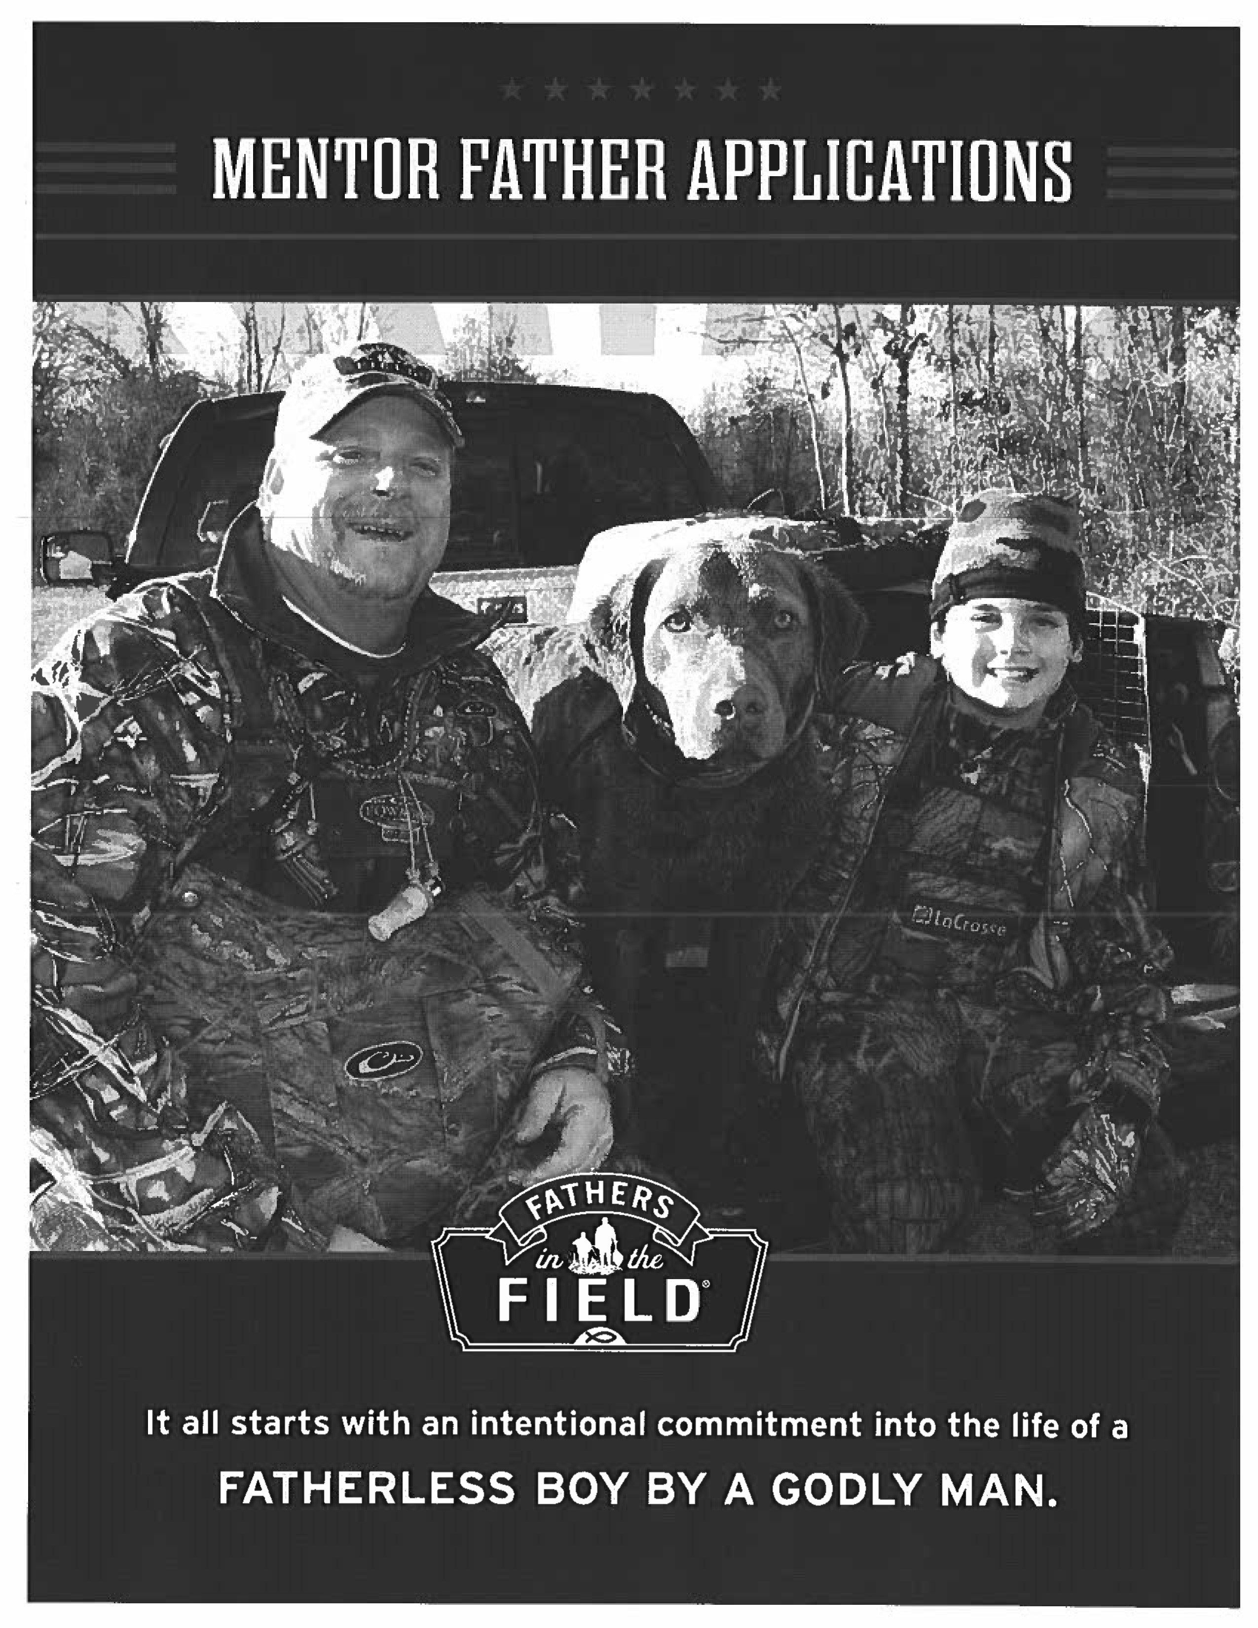
Mentor Father Application Checklist
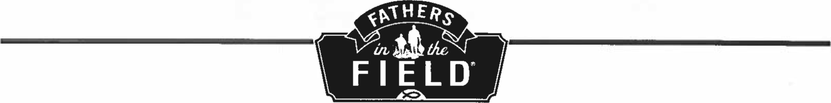
FAITH • FATHERHOOD • FORGIVENESS
(ALL INFORMATION IS CONFIDENTIAL) CHECKLIST:
Part 1:Mentor Father Information
 | Part 2: | Mentor Father Statement of Faith
 | Part 3: | Community Reference (not from within your Church)
 | Part 4: | Background Reference Check Approval
 | Part 5: | Pastor Reference & Approval
 | Part 6: | Mentor Father Invoice Agreement Form (need signed by Approving Pastor)
THERE ARE 12 APPLICATION PAGES, WHICH INCLUDES AGREEMENT FORM. PLEASE SUBMIT ALL 12 PAGES. |  |  | MF IWOICE
Thank you for listening to the heart of God in defending the cause of the fatherless.
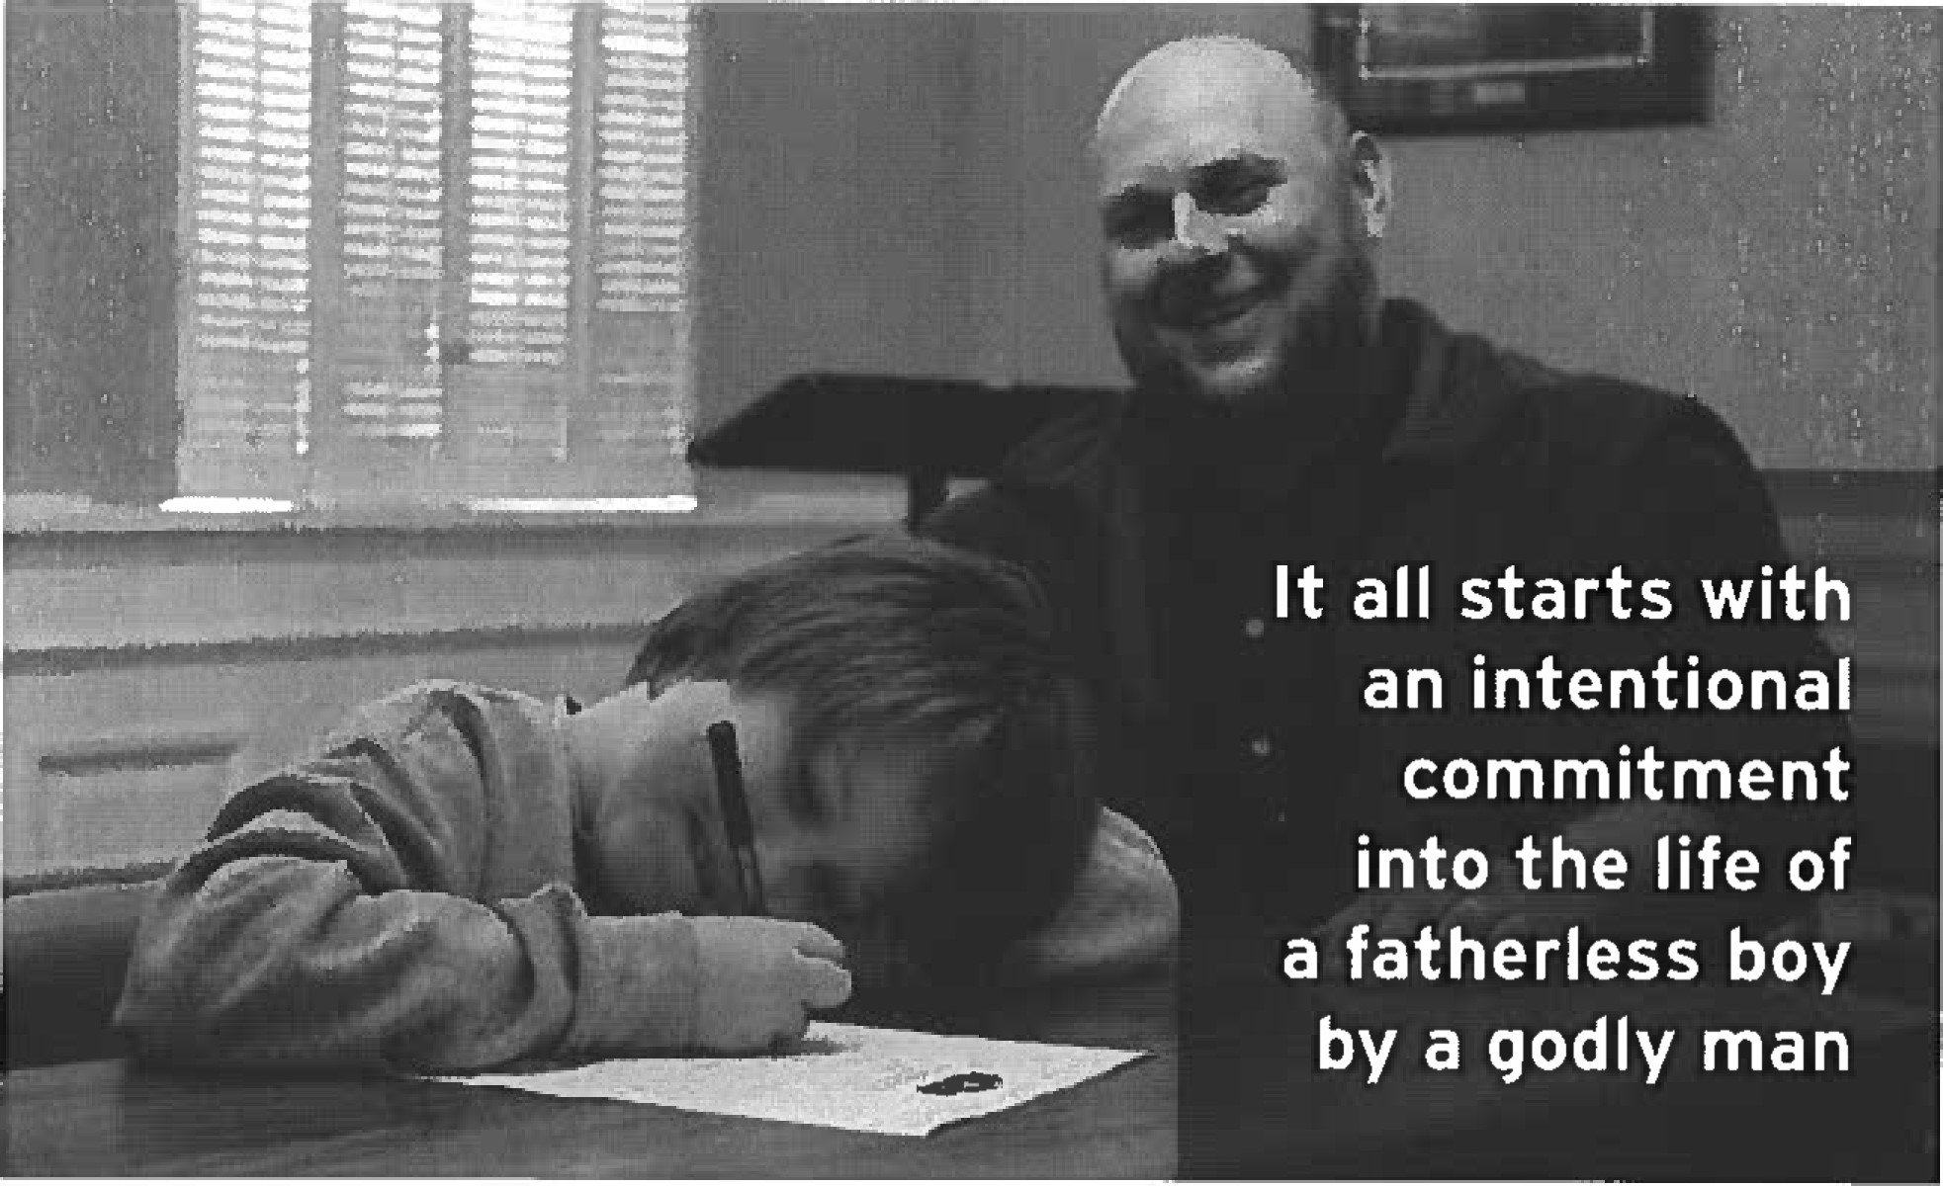
FATHERS
IN
THE
FIELD
FAITH FATHERHOOD • FORGIVENESS
PART - MENTOR FATHER INFORMATION (1 OF 3)

(ALL INFORMATION IS CONFIDENTIAL)
APPLICANT'S NAME
Last Click or tap here to enter text. First Click or tap here to enter text.

Middle Click or tap here to enter text. Preferred Name: Click or tap here to enter text.
End of Year Celebration Event?:Click or tap here to enter text.
(must be decided on and finalized "before" being introduced and paired with a Field Buddy)
ADDRESS
Number & Street Click or tap here to enter text. City Click or tap here to enter text.
State Click or tap here to enter text. Parish Click or tap here to enter text. Zip/Postal _______

PHONE
Home Click or tap here to enter text. Cell Click or tap here to enter text.
Day Click or tap here to enter text. Evening Click or tap here to enter text.
E-MAIL ADDRESS Click or tap here to enter text.

CHURCH INFO
Name Click or tap here to enter text.
Phone Number Click or tap here to enter text. Fax Number Click or tap here to enter text.

BIRTH DATE Click or tap here to enter text.

EMPLOYER
Present Employer Click or tap here to enter text. How long there? Click or tap here to enter text.

EDUCATION
High School Click or tap here to enter text. Graduate Yar Click or tap here to enter text.
Trade School Click or tap here to enter text. Certificate Year Click or tap here to enter text.
College Click or tap here to enter text. Years Attended Click or tap here to enter text.
Degree Click or tap here to enter text. Other Click or tap here to enter text.

MARITAL STATUS
Married ☐ (How long Click or tap here to enter text. )
Divorced ☐ (How Iong) Click or tap here to enter text.)
Married with Children ☐
Never Married ☐
(If applicable) Wife's Name Click or tap here to enter text.

Names and Ages of Children Click or tap here to enter text.

PART I - MENTOR FATHER INFORMATION (2 OF 3)
Name of Mentor Father Click or tap here to enter text.

- What has led you to consider volunteering as a Mentor Father?

Click or tap here to enter text.
- What experience do you have working with children?

Click or tap here to enter text.
- Briefly describe your Christian testimony. (Use back of page if needed.)

Click or tap here to enter text.
- Describe your current church involvement.

Click or tap here to enter text.
- Explain your past and/or present use of alcohol or any other drugs.

Click or tap here to enter text.

PART I MENTOR FATHER INFORMATION (3 OF 3)

Name of Mentor Father Click or tap here to enter text.
- Do you have a valid driver's license? Yes ☐No ☐
State Click or tap here to enter text. Driver's License Number Click or tap here to enter text.

Do you have your own transportation? Yes ☐ No ☐
Please describe your driving record and offenses
Click or tap here to enter text.

Do you have sufficient auto insurance to cover injuries sustained to a passenger? Yes ☐No ☐
- Have you ever been involved in, investigated for, arrested and/or convicted of a crime? Yes ☐ No ☐
When? Click or tap here to enter text.
Explain: Click or tap here to enter text.

- List references: (Your Pastor and one other Community Leader outside the Church)
Name Click or tap here to enter text. Relationship Click or tap here to enter text.
Address Click or tap here to enter text.
Work Phone Click or tap here to enter text. Home Phone Click or tap here to enter text.
Name Click or tap here to enter text. Relationship Click or tap here to enter text.
Address Click or tap here to enter text.
Work Phone Click or tap here to enter text. Home Phone Click or tap here to enter text.
Please list interests, hobbies, and activities you enjoy.
Click or tap here to enter text.

This information is true and accurate to the best of my knowledge.
Signed Click or tap here to enter text. Date Click or tap here to enter text.
FAiTH FATHERHOOD • FORGIVENESS

PART 2 - STATEMENT OF FAITH FOR MENTOR FATHER

F. 1. T. F. STATEMENT OF FAITH

We at Fathers in the Field believe in the following unchangeable truths;
We believe in one God, Creator and Lord ofthe Universe, the co-eternal Trini9t•, Father, Son, and Holy Spirit.
We believe that Jesus Christ, God's Son, was conceived by the Holy Spirit, born of the Virgin Mary, lived a sinless life, died a substitutionary atoning death on the cross, rose bodily from the dead and ascended to heaven where, as truly God and truly man, He is the only mediator between God and man.
We believe that the Bible is God's authoritative and inspired Word. It is without error in all its teachings, including creation, history, its own origins, and salvation. Christians must submit to its divine authority, both individually and corporately, in all matters of belief and conduct, which is demonstrated by true righteous living.
We believe that all people are lost sinners and cannot see the Kingdom of God except through the new birth. Justification is by grace through faith in Christ alone.
We believe in one holy, universal, and apostolic Church. Its calling is to worship God and witness concerning its Head, Jesus Christ, preaching the Gospel among all nations and demonstrating its commitment by compassionate service to the needs of human beings and promoting righteousness and justice.
We believe in the necessity ofthe work ofthe Holy Spirit for the individual's new birth and growth to maturity, and for the Church's constant renewal in truth, wisdom, faith, holiness, love, power, and mission.
We believe that Jesus Christ will personally and visibly return in glory to raise the dead and bring salvation and judgment to completion. God will filly manifest His kingdom when He establishes a new heaven and new earth, in which He will be glorified forever and exclude all evil, suffering, and death.
Signature: Click or tap here to enter text.

Printed NameClick or tap here to enter text. DateClick or tap here to enter text.
Name of Church and Address Click or tap here to enter text.

FAITH • FATHERHOOD FORGIVENESS

PART 3 - COMMUNITY REFERENCE FORM (1 OF 3)
Reference should not be within the Church and not related the applicate. Reference letters do not replace this form,

Section A: TO BE COMPLETED BY THE MENTOR FATHER APPLICANT
MENTOR FATHER'S APPLICANT NAME
Last Click or tap here to enter text. First Click or tap here to enter text.
MiddleClick or tap here to enter text. Preferred Name Click or tap here to enter text.

ADDRESS
Number & Street Click or tap here to enter text.
City Click or tap here to enter text. StateClick or tap here to enter text.
ParishClick or tap here to enter text. Zip/Posta1 Click or tap here to enter text.

PHONE
Home Click or tap here to enter text. Cell Click or tap here to enter text.
Day Click or tap here to enter text. Evening Click or tap here to enter text.
E-MAIL ADDRESS
Click or tap here to enter text.

CHURCH
Name Click or tap here to enter text.
Phone Click or tap here to enter text. Fax Click or tap here to enter text.

I, Click or tap here to enter text. GIVE FATHERS IN THE FIELD PERMISSION TO CONTACT THIS REFERENCE AND WAIVE MY RIGHT TO REVIEW ANY COMMENTS MADE AS A RESULT OF THIS CONTACT.
Applicant's SignatureClick or tap here to enter text.
Applicant's NameClick or tap here to enter text. DateClick or tap here to enter text.
CHURCH NAME & ADDRESS
Name Click or tap here to enter text.
Number & Street Click or tap here to enter text. City Click or tap here to enter text. State Click or tap here to enter text. COUNTY Click or tap here to enter text. Zip/Postal Click or tap here to enter text.

PART 3 • COMMUNITY REFERENCE FORM (2 OF 3)
Section B: TO BE COMPLETED BY COMMUNITY LEADER
Name of Mentor Father
REFERENCE'S NAME (can not be from within your Church or a Relative)
Last Click or tap here to enter text. First Click or tap here to enter text.
Title Click or tap here to enter text.

How long have you known the applicant?

Click or tap here to enter text.
What do you believe to be the applicant's greatest strength?

Click or tap here to enter text.
What do you believe to be the applicant's greatest weakness?

Click or tap here to enter text.
How would you describe the applicant's awareness of his calling as a Christian and of his response to that calling? (Check one)
Very Solid/Mature ☐ Strong/Thriving ☐ Average/Growing ☐ Probable/Developing ☐ Possible/Vague Not apparent☐
(On a scale of 1-10 with 10 being the highest)
How appropriately does the applicant relate to young boys? Click or tap here to enter text.

PART 3 - COMMUNITY REFERENCE FORM (3 OF 3)

Section B: To BE COMPLETED BY COMMUNITY LEADER
Name of Mentor Father Click or tap here to enter text.

Carefully rate the applicant by checking the appropriate rating for each characteristic. On a scale of 1-5, 5 indicates that the applicant excels in that characteristic, and I indicates that the applicant does not demonstrate that characteristic. It is important that you rate the applicant to the best of your knowledge for each characteristic.

COMMUNICATION SKILLS 5☐ 4 ☐ 3 ☐ 2 ☐ 1 ☐

INTEGRITY 5☐ 4 ☐ 3 ☐ 2 ☐ 1 ☐

LEADERSHIP 5☐ 4 ☐ 3 ☐ 2 ☐ 1 ☐

RESPONSIBILITY 5☐ 4 ☐ 3 ☐ 2 ☐ 1 ☐

SELF-DISCIPLINE 5☐ 4 ☐ 3 ☐ 2 ☐ 1 ☐

SENSITIVITY To OTHERS 5☐ 4 ☐ 3 ☐ 2 ☐ 1 ☐
What is your recommendation in respect to this applicant's admission? (Check one)
☐ Strongly recommend ☐Recommend ☐ Recommend with reservations ☐Do not recommend
Please list any circumstances / issues of which the Church should be aware before deciding on the applicant's suitability for a Mentoring Ministry.
Click or tap here to enter text.

SignedClick or tap here to enter text. Date Click or tap here to enter text.

Print Name: Click or tap here to enter text.

CONFIDENTAL
Fathers In the Field Ministry
BACKGROUND CHECK AUTHORIZATION
PART 4 - BACKGROUND CHECK AUTHORIZATION PRINT NAME
First Click or tap here to enter text. Middle Click or tap here to enter text. Last Click or tap here to enter text.
Former Name(s) Click or tap here to enter text. Date Used Click or tap here to enter text.

ADDRESS
CURRENT ADDRESS SINCE Month Click or tap here to enter text. Year Click or tap here to enter text.
Number & Street Click or tap here to enter text.

City Click or tap here to enter text. State Click or tap here to enter text. COUNTY Click or tap here to enter text. Zip/Postal Click or tap here to enter text.
PREVIOUS ADDRESS FROM: Month Click or tap here to enter text. Year Click or tap here to enter text.
Number & Street Click or tap here to enter text.
City Click or tap here to enter text. State Click or tap here to enter text. COUNTY Click or tap here to enter text.
Zip/Postal Click or tap here to enter text.
SOCIAL SECURITY # Click or tap here to enter text. DOB Click or tap here to enter text.

PHONE: Home Click or tap here to enter text. Cell Click or tap here to enter text.
DRIVERS LICENSE
Number Click or tap here to enter text. State Click or tap here to enter text.

The information contained in this application is correct to the best of my knowledge. I hereby authorize Fathers in the Field and its designated agents and representatives to conduct a comprehensive review of my background causing an investigative report to be generated for volunteer purposes. I understand that the scope of the investigative report may include, but is not limited to the following areas: verification of social security number; civil and criminal history records from any criminal justice agency in any or all federal, state, county jurisdictions; driving records, birth records, and any other public records.
I further authorize any corporation, or public agency (including the Social Security Administration and law enforcement agencies) to divulge any and all information pertaining to me, to Fathers in the Field. I further authorize the complete release of any records or data pertaining to me which the corporation, or public agency may have, to include information or data received from other sources.
Fathers in the Field and its designated agents and representatives shall maintain all information received from this authorization in a confidential manner in order to protect the applicants personal information, including, but not limited to, addresses, social security numbers, and dates of birth.
Applicant's Signature Click or tap here to enter text. Date Click or tap here to enter text.
Notice to California, Minnesota and Oklahoma Residents:
Please check the box below if you wish to receive a copy of a report that is requested. I wish to receive a copy of any Background Check Report on me that is requested.
FAITH FATHERHOOD FORGIVENESS

PART 5 - PASTOR'S REFERENCE AND APPROVAL FORM (1 of 3)
References should not be related to the applicant. Reference letters do not replace this form.

Section A: TO BE COMPLETED BY THE MENTOR FATHER APPLICANT
MENTOR FATHER'S APPLICANT'S NAME
Last Click or tap here to enter text. First Click or tap here to enter text.
Middle Click or tap here to enter text. Preferred Name Click or tap here to enter text.
ADDRESS
Number & Street Click or tap here to enter text.
City Click or tap here to enter text. State Click or tap here to enter text. COUNTY Click or tap here to enter text. Zip/Postal Click or tap here to enter text.

PHONE
Home Click or tap here to enter text. Cell Click or tap here to enter text. Fax Click or tap here to enter text.
Day Click or tap here to enter text. Evening Click or tap here to enter text.
E-MAIL ADDRESS
Click or tap here to enter text.
I Click or tap here to enter text.,GIVE FATHERS IN THE FIELD PERMISSION TO CONTACT THIS REFERENCE WAIVE MY RIGHT TO REVIEW ANY COMMENTS MADE AS A RESULT OF THIS CONTACT.
Applicant's NameClick or tap here to enter text.
Applicant's SignatureClick or tap here to enter text. DateClick or tap here to enter text.
CHURCH NAME & ADDRESS
Name Click or tap here to enter text.
Number & Street Click or tap here to enter text.
City Click or tap here to enter text. State Click or tap here to enter text. COUNTY Click or tap here to enter text. Zip/Posta1 Click or tap here to enter text.

PART 5 - PASTOR'S REFERENCE AND APPROVAL FORM (2 of 3)

Sec-don B: TO BE COMPLETED BY PASTOR
Name of Mentor Father Click or tap here to enter text.

PASTOR'S NAME
Last Click or tap here to enter text. First Click or tap here to enter text.
Title Click or tap here to enter text.

How long have you known the applicant?
Click or tap here to enter text.

How long has he been a member of your Church?
Click or tap here to enter text.

What do you believe to be the applicant's greatest strength?
Click or tap here to enter text.

What do you believe to be the applicant's greatest weakness?
Click or tap here to enter text.

How would you describe the applicant's awareness of his calling as a Christian and of his response to that calling? (Check one)
Very Solid/Mature☐ Strong/thriving☐ Average/Growing ☐ Probable/Developing☐ Possible/Vague Not apparent ☐
(On a scale of 1-10 with 10 being the highest)
How appropriately does the applicant relate to young boys? Click or tap here to enter text.

PART 5 • PASTOR'S REFERENCE AND APPROVAL FORM (3 3)
Section B: TO BE COMPLETED BY PASTOR
Name of Mentor Father Click or tap here to enter text.

Carefully rate the applicant by checking the appropriate rating for each characteristic. On a scale of 1-5, 5 indicates that the applicant excels in that characteristic, and I indicates that the applicant does not demonstrate that characteristic. It is important that you rate the applicant to the best of your knowledge for each characteristic.

COMMUNICATION SKLLS 5☐ 4☐ 3☐ 2☐ 1☐

INTEGRITY 5☐ 4☐ 3☐ 2☐ 1☐

LEADERSHIP 5☐ 4☐ 3☐ 2☐ 1☐

RESPONSIBILITY 5☐ 4☐ 3☐ 2☐ 1☐

SELF-DISCIPLINE 5☐ 4☐ 3☐ 2☐ 1☐

SENSITIVITY To OTHERS 5☐ 4☐ 3☐ 2☐ 1☐
Please list any circumstances of which Fathers in the Field should be aware before your decision on the applicant's suitability for your ministry inside your church? If no concerns, please leave blank.
Click or tap here to enter text.

Mentor Father Applicant Names, Click or tap here to enter text. has my APPROVAL to be a Mentor Father.

By signing below, I acknowledge, FitF Mentoring Ministry is not a para-Church Ministry, but only equipping the Church. Therefore, it is our Church's responsibility to have the oversight and accountability as it relates to his Mentoring activities.
Pastor's SignatureClick or tap here to enter text. Date Click or tap here to enter text.
Pastor's Title Click or tap here to enter text.

MENTOR FATHER INVOICE AGREEMENT
The Church / Pastor acknowledges its Approval of the indicated Mentor into their Church's mentoring ministry and is agreeing to be invoiced annually during his mentoring term. Fathers in the Field (FitF) does not approve Mentor Fathers.

PASTOR APPROVED Mentor Father Information:
Name Click or tap here to enter text.
EmailClick or tap here to enter text.
Phone Number: HomeClick or tap here to enter text.CellClick or tap here to enter text.WorkClick or tap here to enter text.
Address:Click or tap here to enter text.
CityClick or tap here to enter text.StateClick or tap here to enter text.Zip:Click or tap here to enter text.

Church NameClick or tap here to enter text.
Number ofYears Mentor Father has been Attending your Church: Click or tap here to enter text.
Commissioning Date of Mentor Father (approximately): month: Click or tap here to enter text.
End of Year Celebration Event Description: Click or tap here to enter text.

PROGRAM MATERIAL PURCHASE:
PLEASE NOTE: A National Backwound Check with any additional state and county Fees are included in the Purchase cost for each Mentor Father as a requirement even if it is a second or duplicated Check by the Church. We just want to make sure it gets done.
Yearly Mentor Father cost: The Church will be invoiced $500 annually on his anniversary month.
Payment Method: Please make check payable to:
Fathers in the Field Ministry at 6796 N. Franklin Ave, Loveland, CO 80538
Additional Terms: reverse side of this Commitment contains additional terms which are a part of this agreement between the Church and FitF. The undersigned has read both sides of this Commitment and understands and acknowledges that all terms on the front and back of this Commitment are part of the agreement between the Church and FitF.
CHURCH:
Pastor Approval of Mentor Father Signature:Click or tap here to enter text.

Print Name Click or tap here to enter text.

Title Click or tap here to enter text. Date Click or tap here to enter text.
PLEASE RETURN TO: Regional Missionary: Click or tap here to enter text.
Thank you for listening the heart of God, and responding to cry of the abandoned boy. Fathers in the Field is a 501c3 charitable organization.

